**TESS**

**CNN-1 [ Conv: 4, Dense: 1 ]**

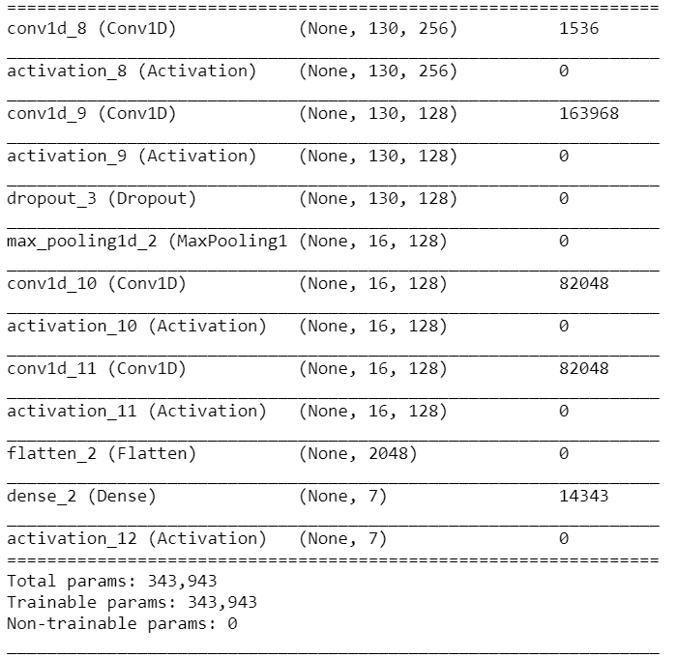

Training Accuracy: 100%

Validation Accuracy: 88.57%